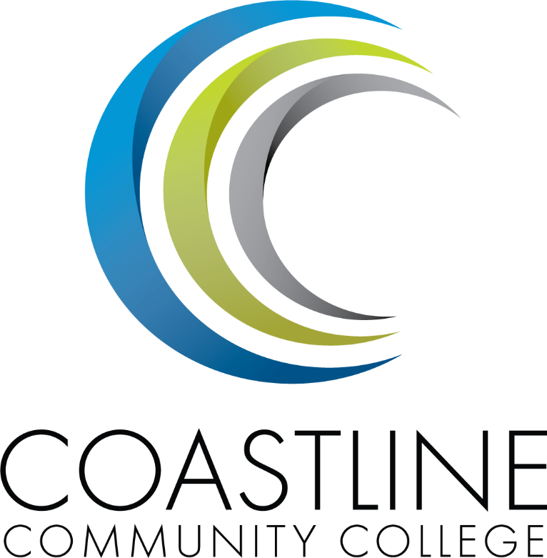

Enrollment Management Plan

2017-2020

Table of Contents
Table of Contents
Mission Statement 3
Organizational Structure 3
Technology 3
Background 4
Guiding Principles for Enrollment Planning 4
Philosophical Framework 4
Planning Assumptions 5
Strategies 5
Campuses 7
The College Center 7
The Garden Grove Campus 7
The Westminster Le-Jao Campus 7
The Newport Beach Campus 8
Key Performance Indicators 9
Academic Schedule Plan 12
Modality 12
History 14
The Coast Community College District 14
Coastline Community College 14
Background 18
Business Development and Technology Solutions 20
Looking Forward 20
External Scan 21
Population of OC 21
Economics of Orange County 32
Educational Competition in Orange County 36

Given that Instruction and Student Services are integral to each other in Coastline’s support of student achievement and success, the next iteration of this Enrollment Management Plan (2019) will weave in Student Services Wing strategies that work towards meeting students’ and the institution’s goals in regard to recruitment, retention, and achievement.

Mission Statement

Coastline Community College steadfastly focuses on providing access and supporting student success and achievement. Inspired by an innovative and student-centered mindset, Coastline delivers flexible courses and services that cultivate and guide diverse student populations across the globe to complete pathways leading to the attainment of associate degrees, certificates, career readiness, and transfer to four-year colleges/universities.

Organizational Structure

The organizational structure of the college is composed of four operational wings, which include Administrative Services, Instructional Services, President’s, and Student Services.

Figure 1.1 Organizational Chart
College President

Administrative Services Wing

Student Services Wing
President’s Wing
Instructional Services Wing

- Campus Safety and Emergency Management
- Fiscal Services
- Human Resources
- Maintenance and Operations

- Arts and Sciences
- (Newport Beach Center)
- Career and Technical Education
- (Garden Grove Center)
- Distance Learning
- Humanities and Basic Skills (Le-Jao Center)
- Professional Development
- Admissions & Records
- Assessment
- CalWORKs
- Career Center
- Counseling
- EOPS
- Financial Aid
- Outreach
- Student Life
- Transfer Center
- Foundation
- Institutional Effectiveness, Research, Planning, and Grant Development
- Marketing & Public Relations
- Military Education, Corporate Training, Business, and Extended Learning

Technology
Coastline is a recognized leader in the design, development, and use of innovative technology-based teaching and learning practices, processes, and systems for anytime-anywhere learning to achieve and sustain outstanding student success. Coastline uses technology in innovative and creative ways to enhance the learning environment and success of traditional and nontraditional students anytime and anywhere while providing state-of-the-art support and services to faculty and staff. Coastline is a leader and champion of continuous evaluation and testing of new and emerging technology and is willing to rapidly transform programs, processes, and practices to improve student success through the innovation and application of new technology.

Background
From 2012-2013 to 2015-2016 Coastline Community College increased FTES by 28.5% which provided significant FTES to assist the District in reach base enrollment. However, in 2016-2017 the FTES declined by approximately 300. However, the College continues to meet our base FTES. This enrollment management plan provides a framework for intentionally utilizing marketing, scheduling, staffing, and professional development in a strategic way in order to:

- Identify and Meet Enrollment Goals
  - FTES
  - Balance of Programs
  - Onsite and Distance Education Balance
- Ensure Access
- Increase Student Success Key Performance Indicators

Guiding Principles for Enrollment Planning
This enrollment management plan will support District Strategic Plan goals and College Strategic Plan Areas of Focus:
- District Strategic Plan Goals:
  - Area 1: Student Learning and Achievement
  - Area 2: Stewardship of Resources
  - Area 3: Community Engagement and Partnerships
  - Area 4: Workplace Engagement & Satisfaction and Effectiveness of District-wide Participatory Governance
- College Strategic Areas of Focus
  - Student Success, Completion, and Achievement
  - Instructional and Programmatic Excellence
  - Access and Student Support
  - Student Retention and Persistence
  - Culture of Evidence, Planning, Innovation, and Change
  - Partnerships and Community Engagement
  - Fiscal Stewardship, Scalability, and Sustainability

Philosophical Framework
This plan will address global, National, State, and local educational needs to increase access to College, increase College graduates, increase the number of students prepared for transfer to universities, and provide an educated workforce. Scheduling of classes will continue to be prioritized based on graduation and transfer requirements, career and technical education certificates, and basic skills improvement.

Planning Assumptions
Coastline Community College will:
- continue to provide educational opportunities for students where they live and work. This includes our global, traditional, and non-traditional students.
- continue to serve incarcerated students. However, the College will strategically manage the number of incarcerated students so as to not increase the percentage of incarcerated student headcount.
- grow FTES to 6,700 by 2019-2020 (3%-4% annually).
- maintain WSCH/FTEF above 600
- increase site based enrollments and continue to improve space utilization (cap:load ratios)
- increase the number of full-time students
- continue to leverage our expertise in distance education through scheduling and advertising.
- increase collaboration and partnerships with local feeder high school districts through programs such as dual enrollment, the College Promise, faculty collaboration on professional development and workshops with our K-12 partners.
- maintain our commitment to serving active duty military and veterans.
- increase opportunities for career advancement and working adults through collaboration and partnerships with local and national business and industry
- recognize prior learning toward certificate and degree attainment
- use data to inform decision making

Strategies

- Identify and remove barriers for students entering the college, enrolling in classes, staying enrolled, and achieving their goals
- Pathways
    - Provide students with Career Clusters and list degrees/programs to support students as they pursue their transfer and career options.
    - Simplify student onboarding to increase the number of applicants who enroll in classes.
        - Enhance student orientations
    - Provide students seamless and convenient opportunity to complete certificates and degrees
      - Departments will create roadmaps for all degree and certificate options.
      - Develop student-centered schedules, increase space utilization and reduce time to certificate and degree completion.
        - Block scheduling will be used for site based classes
        - Classes will be scheduled so students may complete all the requirements of a degree at one of the campuses.
        - Certificates will be stackable ultimately leading to Certificate of Achievement and Associate Degree completion
      - Implement a College Promise program
    - Keep students on their path.
      - Provide appropriate support and resources will be provided for student services and instructional programs.
      - Faculty advisors will support students as they explore careers and progress through instructional programs (these are likely to be FT faculty and Department Chairs who will meet with student from their disciplines or field of study – not counseling functions).
      - The Student Success Center will continue to be provided appropriate budget to provide tutoring and supplemental instruction.
      - Provide appropriate instructional associates for laboratory and specialized classes.
      - Leverage predictive analytics (e.g. Civitas) to create early alert for students at risk of failure and to provide intervention.
      - Provide professional development focused on student success
    - Ensure students are learning
- Productivity
  - Expand partnerships with local high school districts.
  - Develop dual enrollment programs at local high schools
  - Improve and expand concurrent enrollment programs for high school students
  - Develop non-credit enhanced funded programs.
  - Review and adjust class schedules to reduce the percentage of low enrolled/low productivity classes.
  - Continue to grow Cyber Security and CTE offerings and activities
  - Continue to grow short-term training programs (fee-based, non-credit and credit)
- Develop a comprehensive Marketing and Recruitment Plan
  - In-Reach
    - Improve communication with students who have already applied or enrolled.
  - Outreach Strategies
    - Coordinate all outreach activities across the College.
    - Expand articulation and guaranteed transfer with universities.
    - Develop an international recruitment plan.
    - Create a discipline outreach program to target specific programs and build a continual flow of students via the partnerships with Coastline College programs and surrounding high school and community programs.
    - Expand partnerships with elementary, middle, and high schools for career and college exploration programs.
    - Enhance business development, outreach, & recruitment activities to more effectively reach working adults and increase business and industry partnerships.

Campuses

The College Center
Prior to 1984, core college activities were housed in a leased office space on Slater Avenue in Fountain Valley across the street from City Hall. In the fall of 1984, the Board of Trustees officially dedicated a permanent College Center located at 11460 Warner Avenue in Fountain Valley. The land acquisition and construction were financed by issuance of low-interest, tax-exempt “participation notes” and did not place any obligation on taxpayers. The four-story, 48,000 square-foot building provided a new and permanent home for Student Services, Administrative Services, the Office of Instruction, Distance Learning Support, Coast Learning Systems, and Graphics and Publications. Part of the plan for this 8.3-acre property was to use the additional space to develop and lease a commercial facility.

The College Center has undergone numerous improvements and renovations over the years, including the addition of a permanent Bookstore, the expansion and relocation of departments, and the dedication of the College’s first Veterans’ Resource Center (VRC), which offers academic counseling, evaluation of military credit, mental health and disability services referrals, employment and housing referrals, VA paperwork assistance, and peer support. The VRC also offers veterans complimentary access to computers, copiers, fax machines, snacks, and coffee.

Today at the College Center, students will find the Admissions Office, the Distance Learning Office, the Military and Contract Education Department, the Bookstore, the Assessment Center, the Counseling Department, the Transcript Office, the Career Service Office, the Student Life Office, Financial Aid and EOPS/CARE programs, the Foundation Office, tutoring services, and the Office of the President and College Vice Presidents’ offices.

The Garden Grove Campus
In the early ‘90s the Coast Community College District held an initial meeting with the Garden Grove Redevelopment Agency to discuss a long-term lease for a parcel of land near the corner of Euclid and Garden Grove Boulevard. In May of 1994, the City of Garden Grove accepted the proposal and agreed to transfer 4.5 acres of land to the District with a stipulation that a higher education facility be built. In the spring of 1994, the college established a “design team” of faculty and staff to advise on programs and services to be housed at the new center. The project began in October of 1995. Two years later, the state-of-the-art, three-story, 45,000-square-foot facility opened and became fully operational. Today the facility houses an Information Commons, which doubles as the incident command center for disaster preparedness, computer labs, two large lecture classrooms, a viewing center for Distance Learning courses, a full-service Student Success Center, a chemistry lab, a fully interactive CODEC classroom for video conferencing, a Counseling and Transfer Center, several general classrooms, the STAR fast-track program, Career Technical Education (CTE) curriculum, and adjustable student gathering spaces.

The success of this center inspired the District and the College to build upon an emerging new concept for the College in keeping with its founding philosophy but more rooted in the communities through substantial, visible, and permanent campuses distributed among areas of the District.

The Westminster Le-Jao Campus
The first building in the District completed with bond funding was Coastline’s Westminster Le-Jao Campus, which is a 36,000 square foot facility constructed in Westminster across the street from the Westminster Civic Center. This is the third permanently owned facility within Coastline’s distributed campus structure. It opened for classes in spring 2006, with well-equipped classrooms. This two-story facility has staff offices, counseling offices, faculty office space, one science wet lab, computer labs, general classrooms, a student lounge, and a Student Success Center. All classes at the formerly leased Huntington-Westminster Center were the first courses to be moved to the new Le-Jao Center. This facility houses the College’s Access Program, the ESL Program, and an ESL lab.

The Newport Beach Campus
In August 2009, the College closed escrow on two parcels of land totaling about 3.9 acres in a residential neighborhood in Newport Beach. The land for the Center was purchased from voter-approved “Measure C” bonds. Groundbreaking took place in February 2011. Coastline received the 2012 Award for Environmental Excellence from the Orange County League of Conservation Voters for its commitment to sustainable building practices of the Newport Beach campus. In spring 2013, Coastline completed construction on the Newport Beach Center, which is a three-story, 67,000-square-foot building overlooking the Pacific Ocean. The building is designed at the level of gold according to the energy efficiency standards developed by the Leadership in Energy & Environmental Design (LEED). All courses offered at the leased Costa Mesa Center site were initially moved to this new center. Programs housed at Newport Beach include the art program; the Acquired Brain Injury (ABI) program, which is a world-renowned program designed to provide structured cognitive retraining for adults who have sustained a brain injury due to traumatic or non-traumatic injuries; the Paralegal Studies Program; and most recently, all Science, Technology, Engineering, Art, and Mathematics (STEAM) curriculum. There is also a dedicated Art Gallery onsite (originally opened at a leased facility in Huntington Beach), the College’s second Veterans’ Resource Center, a full-service kitchen, and ample gathering space for students.

Key Performance Indicators

Student Success, Completion, and Achievement | 2014-15 | 2015-16 | 2016-17 | College Standard
Overall Course Success | 69.5% | 70.1% | 70.7% | 60.1%
Traditional Course Success | 80.3% | 80.5% | 81.8% | 69.5%
Online Course Success | 70.6% | 70.9% | 71.7% | 60.9%
Hybrid Course Success | 62.2% | 66.7% | 74.2% | 63.1%
Correspondence Course Success | 63.4% | 64.9% | 64.6% | 54.9%
Coastline State-Funded Success | 65.4% | 66.7% | 68.1% | 57.9%
Traditional Course Success | 80.5% | 80.6% | 81.8% | 69.5%
Online Course Success | 63.2% | 64.5% | 67.1% | 57.0%
Hybrid Course Success | 62.1% | 67.6% | 74.2% | 63.1%
Correspondence Course Success | 61.7% | 63.9% | 63.5% | 54.0%
Extended Learning Success | 83.9% | 83.5% | 83.2% | 70.7%
Overall Completion | 51.8% | 50.0% | 48.8% | 41.5%
Prepared Completion | 71.4% | 69.4% | 66.8% | 56.8%
Underprepared | 40.2% | 39.3% | 36.6% | 31.1%
CTE Completion | 55.2% | 57.4% | 59.9% | 50.9%
Number of Degrees | 1,882 | 2,109 | 2,220 | 1887
Coastline General Fund Degrees | 737 | 850 | 1,027 | 873
Extended Learning Degrees | 1,145 | 1,259 | 1,193 | 1014
Number of Certificates | 644 | 547 | 602 | 512
Coastline State-Funded Certificates | 457 | 415 | 375 | 319
Extended Learning Certificates | 291 | 229 | 227 | 193
Number of Graduates (Overall) | 1,558 | 1,606 | 1,565 | 1,330
Transfer Volume (Overall) | 3,865 | 4131 | 4078 | 3466
Transfer Volume (Overall) 12+ units | 1,209 | 1388 | 1392 | 1183
Transfer Volume (UC CSU) | 284 | 354 | 340 | 289
Transfer Rate | 26.9% | 31.5% | 31.5% | 26.8%
Job Placement Rate | 25.5% | 25.5% | 29.1% | 24.7%
Academic and Programmatic Excellence | 2014-15 | 2015-16 | 2016-17 | College Standard
Number of Courses Reviewed | 126 | 112 | 149 | 127
New Degrees and Certificates | 6 | 12 | 4 | 3
New Courses Developed | 12 | 31 | 32 | 27
Number of Professional Development Events | - | 15 | 18 | 15
Employee Satisfaction with Services | - | 91.6% | 93.4% | 79.4%
Access and Student Support | 2014-15 | 2015-16 | 2016-17 | College Standard
AAPI Percentage (Degree, Certificate, or Transfer Seeking) | 16.3% | 16.5% | 19.9% | 14.0%
HSI Percentage (Degree, Certificate, or Transfer Seeking) | 24.2% | 26.5% | 31.2% | 22.5%
Number of Applications | 33,622 | 29,460 | 30,694 | 25,041
Percent of Students that enrolled after applying | 50.9% | 51.9% | 47.9% | 44.1%
1st Time Student Fall (Percent that are Degree, Certificate, or Transfer Seeking) | 76.9% | 77.9% | 75.9% | 66.2%
Percent of Full-time Students (Degree, Certificate, or Transfer Seeking) | 13.6% | 14.6% | 13.9% | 12.4%
Coastline State-Funded Percent of Full-time Students (DCT Seeking) | 15.7% | 15.7% | 15.0% | 13.4%
Coastline Extended Learning Percent of Full-time Students (DCT Seeking) | 8.1% | 10.4% | 9.7% | 8.8%
Number of Student Assessments Given (English and Math) | 4,533 | 4,680 | 5,569 | 3,978
Number of Education Plans (Comprehensive and Abbreviated) | 7,284 | 8,265 | 9,650 | 7,025
Number of Comprehensive Education Plans | 1,527 | 2,835 | 3,072 | 2,410
Number of Students Using Library Databases | 81,051 | 75,815 | 76,903 | 64,443
Number of Students Using Tutoring | 3,376 | 3863 | 6139 | 5,218
Student Retention and Persistence | 2014-15 | 2015-16 | 2016-17 | College Standard
Overall Courses Retention | 85.7% | 86.1% | 85.8% | 73.2%
Traditional Retention | 89.7% | 89.1% | 90.1% | 75.7%
Online Retention | 85.6% | 85.5% | 85.2% | 72.6%
Hybrid Retention | 80.5% | 80.3% | 86.2% | 68.3%
Correspondence Course Retention | 84.5% | 86.4% | 85.3% | 73.5%
Coastline State-Funded Retention | 82.3% | 83.3% | 83.6% | 70.8%
Traditional Retention | 90.0% | 89.3% | 90.1% | 75.9%
Online Retention | 79.5% | 80.4% | 81.4% | 68.3%
Hybrid Retention | 80.5% | 81.3% | 86.2% | 69.1%
Correspondence Course Retention | 82.6% | 85.1% | 84.1% | 72.3%
Extended Learning Retention | 97.6% | 97.0% | 96.4% | 82.4%
Fall to Fall Persistence | 54.7% | 68.0% | 72.3% | 57.8%
Basic Skills English Progression | 47.6% | 47.7% | 48.1% | 40.5%
Basic Skills Math Progression | 22.6% | 28.8% | 33.7% | 24.5%
ESL Progression | 17.5% | 28.0% | 24.9% | 23.8%
Culture of Evidence, Planning, Innovation, and Change (EPIC) | 2014-15 | 2015-16 | 2016-17 | College Standard
ISLO1. Demonstrate ability to apply critical thinking and analysis. | 51.5% | 85.3% | 75.3% | 47.9%
ISLO2. Demonstrate ethical civic, environmental, and social responsibility. | 59.0% | 81.7% | 84.5% | 51.4%
ISLO3. Demonstrate information competency. | 60.5% | 79.0% | 78.7% | 49.6%
ISLO4. Demonstrate innovative thinking, and adaptive, creative problem solving skills. | 43.2% | 80.3% | 79.0% | 42.6%
ISLO5. Demonstrate understanding and appreciation for the visual and performing arts. | 67.7% | 64.7% | 76.6% | 54.1%
ISLO6. Demonstrate understanding and respect for cultural and global diversity. | 50.0% | 76.5% | 79.7% | 45.4%
ISLO7. Use effective communication and interpersonal skills. | 57.7% | 84.2% | 85.5% | 47.9%
ISLO8. Use scientific and quantitative reasoning. | 43.8% | 73.7% | 57.5% | 43.6%
Service Area Outcome Results | 83.3% | 83.9% | 94.4% | 80.2%
Program and Department Review Completion Rate | 91.7% | 100.0% | 100.0% | 85.0%
New Program and Department Review Initiatives | 88 | 76 | 103 | 65
Governance: Collaboration | 56.7% | 67.7% | 65.3% | 57.5%
Governance: Transparency | 52.2% | 60.8% | 61.2% | 51.7%
Governance: Evidence-Based | 47.8% | 56.2% | 49.6% | 47.8%
Governance: Effective | 44.4% | 47.7% | 54.2% | 40.5%
Governance: Efficient | 38.9% | 50.8% | 52.5% | 43.2%
Partnerships and Community Engagement | 2014-15 | 2015-16 | 2016-17 | College Standard
Educational Partnerships | 17 | 20 | 22 | 17
Business Partnerships | 9 | 10 | 12 | 9
Foundation Partnerships | 14 | 12 | 20 | 10
Number of Student Life Events | 53 | 106 | 121 | 90

Fiscal Stewardship, Scalability, and Sustainability | 2014-15 | 2015-16 | 2016-17 | College Standard
Overall Coastline Enrollment | 76,398 | 77,906 | 72,213 | 66,220
Coastline State-Funded Enrollment | 60,022 | 62,645 | 59,386 | 53,248
Coastline Extended Learning Enrollment | 16,376 | 15,261 | 12,797 | 12,972
Overall Unduplicated Headcount | 28,451 | 28,873 | 27,327 | 24,542
Coastline State-Funded Headcount | 21,323 | 22,145 | 21,450 | 18,823
Coastline Extended Learning Headcount | 7,128 | 6,728 | 5,877 | 5,719
FTES (Resident) | 6,058 | 6,343 | 5,928 | 5,669
WSCH/FTEF 595 | 638 | 604 | 569 | 513
Annual Grant Dollars Awarded | 903,974 | 1,250,452 | 2,120,651 | 1,062,884
Annual Foundation Revenue | 892,559 | 838,480 | 899,092 | 712,708
Annual Extended Learning Revenue | 8,641,072 | 7,955,420 | 7,383,005 | 5,900,000
Full-Time Obligation Number CCCD | 414 | 437.9 | 443 | 372
50% Law CCCD | 50.5% | 51.8% | 51.6% | 50.0%
Percent Reserve CCCD | 8.0% | 8.0% | 10.0% | 6.8%
Student Loan Default Rate | 10.5% | 15.7% | 16.0% | 20.0%
Accreditation Standing | Good | Good | Good | Good

Table # Fall headcount proportion by student type
Fall | 2014 | 2015 | 2016 | 2017
First-Time Student | 11.1 % | 8.9 % | 16.8 % | 17.1 %
First-Time Transfer Student | 20.1 % | 21.2 % | 21.5 % | 22.9 %
Returning Student | 10.1 % | 13.0 % | 11.2 % | 11.5 %
Continuing Student | 56.0 % | 53.1 % | 46.2 % | 44.3 %
Uncollected/Unreported | 0.0 % | 0.0 % | 0.0 % | 0.0 %
Special Admit Student | 2.7 % | 3.7 % | 4.4 % | 4.2 %

Academic Schedule Plan
For 2017-2018 the instructional wing is focusing attention on adding daytime classes at Garden Grove and Newport Beach. In addition, increasing night time classes at Newport Beach so students may easily complete the most highly sought after AA degree programs without needing to attend multiple campuses. In developing the schedule of classes we have been moving to block scheduling so students are able to take more than one class in the morning and they may maximize their time on campus. The emphasis no daytime programs at the Garden Grove Center is due to the current availability of classrooms and the abundance of restaurants available within walking distance of the center. The decision to focus on evening AA programs at Newport Beach is due to the availability of classroom at the center in the evening while the other campuses have significant offerings in CTE or ESL. After growing the daytime enrollments at the Garden Gove Center and nighttime enrollments at the Newport Beach Center, the Instructional Wing will then consider the balance of programs offered at the Le-Jao Center.

Modality
Res FTES | 2012-2013 | 2013-2014 | 2014-2015 | 2015-2016 | 2016-2017 | 2017-2018 | 2018-2019 | 2019-2020
Face-to-Face | 1814 | 1599 | 1475 | 1467 | 1317 | 1370 | 1430 | 1490
Hybrid | 65 | 53 | 108 | 123 | 114 | 120 | 125 | 130
Online | 2126 | 2404 | 2789 | 2918 | 2784 | 2860 | 3055 | 3300
Correspondence | 920 | 1443 | 1686 | 1822 | 1847 | 1850 | 1840 | 1800
Total | 4925 | 5499 | 6058 | 6330 | 6062 | 6200 | 6450 | 6700

Enrollment | 2012-2013 | 2013-2014 | 2014-2015 | 2015-2016 | 2016-2017 | 2017-2018 | 2018-2019 | 2019-2020
Face-to-Face | 31.10% | 24.60% | 21.20% | 20.50% | 19.20% | 22.10% | 22.17% | 22.09%
Hybrid | 1.40% | 1.10% | 1.60% | 1.80% | 1.70% | 1.94% | 1.94% | 1.94%
Online | 46.80% | 46.10% | 46.50% | 46.50% | 46.50% | 46.13% | 47.21% | 48.96%
Correspondence | 20.70% | 28.20% | 30.70% | 31.20% | 32.60% | 29.84% | 28.68% | 27.01%

FTES/FTEF | 2012-2013 | 2013-2014 | 2014-2015 | 2015-2016 | 2016-2017 | 2017-2018 | 2018-2019 | 2019-2020
Face-to-Face | 543 | 456 | 406 | 372 | 371 | 380 | 390 | 400
Hybrid | 400 | 217 | 300 | 334 | 294 | 300 | 310 | 320
Online | 689 | 632 | 634 | 602 | 567 | 600 | 600 | 600
Correspondence | 1646 | 1632 | 1647 | 1535 | 1417 | 1420 | 1420 | 1420
Total | 685 | 646 | 638 | 604 | 587 | 600 | 605 | 605

Academic Year | 2012-2013 | 2013-2014 | 2014-2015 | 2015-2016 | 2016-2017 | 2019-2020
Accounting | 162 | 171 | 212 | 197 | 168 | 210
Anthropology | 43 | 58 | 67 | 93 | 93 | 105
Arabic | 0 | 0 | 0 | 2 | 3 | 2
Art | 203 | 162 | 156 | 140 | 130 | 140
Astronomy | 26 | 52 | 81 | 83 | 91 | 110
Biology | 443 | 454 | 446 | 526 | 501 | 530
Building Codes Technology | 24 | 29 | 37 | 45 | 33 | 40
Business | 265 | 391 | 437 | 414 | 422 | 460
Business Computing | 82 | 90 | 129 | 126 | 79 | 125
Chemistry | 136 | 188 | 212 | 239 | 194 | 225
Chinese | 10 | 14 | 9 | 10 | 13 | 14
Communication Studies | 67 | 69 | 56 | 52 | 46 | 54
Computer Information Systems | 28 | 26 | 32 | 32 | 33 | 90
Computer Services Technology | 122 | 111 | 133 | 125 | 134 | 180
Counseling | 103 | 148 | 171 | 182 | 169 | 181
Digital Graphic Applications | 52 | 36 | 47 | 56 | 27 | 70
Economics | 57 | 48 | 54 | 51 | 48 | 80
Education | 15 | 16 | 24 | 27 | 27 | 30
Emergency Management | 34 | 33 | 31 | 27 | 25 | 31
English | 278 | 312 | 314 | 334 | 357 | 385
English as a Second Language | 502 | 414 | 315 | 278 | 216 | 125
Foods & Nutrition | 65 | 106 | 105 | 117 | 117 | 120
French | 17 | 21 | 18 | 16 | 17 | 18
Geography | 4 | 14 | 28 | 33 | 29 | 30
Geology | 90 | 100 | 132 | 137 | 134 | 140
Gerontology | 11 | 9 | 8 | 7 | 6 | 10
Health | 96 | 116 | 151 | 135 | 121 | 135
History | 177 | 228 | 262 | 282 | 286 | 310
Human Services | 27 | 27 | 26 | 29 | 27 | 40
Humanities | 64 | 64 | 74 | 93 | 74 | 80
Italian | 0 | 0 | 2 | 0 | 0 | 0
Japanese | 0 | 0 | 0 | 5 | 10 | 11
Kinesiology | 0 | 4 | 7 | 8 | 6 | 10
Law | 87 | 76 | 75 | 69 | 71 | 80
Learning Skills | 1 | 0 | 0 | 0 | 0 | 0
Library | 2 | 1 | 1 | 2 | 1 | 1
Management & Supervision | 73 | 96 | 77 | 92 | 83 | 95
Marine Science | 29 | 37 | 44 | 47 | 51 | 60
Mass Communications | 74 | 90 | 107 | 103 | 93 | 95
Mathematics | 400 | 479 | 596 | 668 | 702 | 720
Music | 30 | 30 | 38 | 35 | 52 | 60
Philosophy | 180 | 203 | 212 | 214 | 201 | 220
Photography | 1 | 1 | 1 | 0 | 0 | 0
Physical Education | 13 | 18 | 20 | 20 | 20 | 20
Physics | 32 | 35 | 33 | 38 | 39 | 45
Political Science | 117 | 119 | 115 | 115 | 112 | 120
Process Technology | 22 | 19 | 17 | 25 | 29 | 50
Psychology | 207 | 287 | 346 | 365 | 363 | 400
Reading | 0 | 0 | 2 | 2 | 0 | 0
Real Estate | 29 | 25 | 29 | 30 | 30 | 35
Sociology | 105 | 139 | 193 | 203 | 229 | 250
Spanish | 126 | 145 | 183 | 196 | 167 | 170
Special Education | 153 | 143 | 136 | 138 | 133 | 140
Speech | 3 | 0 | 0 | 0 | 0 | 0
Supply Management | 0 | 0 | 3 | 1 | 2 | 4
Vietnamese | 36 | 46 | 53 | 66 | 42 | 44
Total | 4923 | 5500 | 6057 | 6330 | 6056 | 6700

Appendix A

History

The Coast Community College District
In 1947, the Orange Coast Junior College District was formed. A year later, the District opened its first college, Orange Coast College (OCC), in Costa Mesa, using facilities that had served as a U.S. Army Base. By 1966, the growing population of the District’s 105-mile, 11-city service area prompted the opening of a second college, Golden West College (GWC) in Huntington Beach. With the opening of the second college, the District changed its name to the Coast Community College District (CCCD), which it is still known by today.

In 1972, the CCCD had become one of three community college districts in California to own and operate a public television station, KOCE-TV (Channel 50). The station was used to broadcast credit courses. As the District population continued to grow, a new type of student emerged: working adults who could not attend college during the day. An evening college was established to cater to this segment of the community not yet served by any other college in Orange County, and enrollment in the program exploded. A task force of District faculty and staff was formed to analyze the needs of this new market segment and make recommendations on how best to serve this non-traditional student.

It became apparent the constraints inherent in the scheduling and delivery of traditional college instruction were denying access to prospective students. To overcome these barriers, the founders conceived two new means of access: the distributed campus and distance learning. The distributed campus would deliver instruction at locations near where students work and live. Distance learning would deliver instruction through a virtual campus accessible from anywhere at any time. The delivery vehicle would be a new institution known as Coastline Community College (Coastline), founded in 1976.

Coastline Community College
Coastline was charged with assuming responsibility for instruction offered at numerous community locations, broadcast over public television station KOCE, and offered via radio and other distance-education modalities. To support these instructional directives, an instructional design team was formed, and new distance learning evolved. Even with this lofty charge, Coastline was established more quickly than any other new college in California. In a short time period, administrators, staff, and faculty were hired, and then, in a three-month timeframe, the College applied for accreditation and other certification by a multitude of agencies, established a comprehensive curriculum, located more than 100 sites for instruction (banks, senior centers, high schools, office buildings, shopping malls, and other community-based facilities), equipped an administrative headquarters, and enrolled more than 18,000 credit students for classes beginning fall of 1976. The College still boasts that its opening day enrollment is the largest opening-day student population in community college history.

Two traits have characterized Coastline since it was founded in 1976. One is steadfastness of purpose. Conceived as a “college without walls,” Coastline has remained true to the founders’ motto: “The community is our campus; its citizens are our students.” The other constant is a commitment to change as an institutional dynamic. There is a steadfast determination to approach problems creatively and to view obstacles as opportunities. The College is proud to be one of 114 comprehensive community colleges in California but is also proud and protective of its unique characteristics and non-traditional methods of responding quickly to the changing needs and circumstances of students, community, and the larger world.

Coastline has kept pace with change through constant evaluation and evolution of its programs, services, delivery modalities, and learning environments. Over the years the College progressively phased out the delivery of instruction at churches, area sites, elementary schools and other leased sites; and invested in larger, dedicated, but still distributed campuses in cities within the College’s service area.

In the 40 years since Coastline began, the strategies it pioneered have yielded outstanding results. Coastline not only developed an international reputation as an innovative academic community; but also achieved national prominence in distance education, including 20 Emmy Awards and many other awards, as a developer and producer of distance-learning courseware. Today, the courses are highly popular with students: 84 percent of Coastline credit full-time equivalent students (FTES) were distance-learning courses in fall 2015 (not including contract education enrollments). In addition, more than 400 colleges in the United States and Canada license and/or have licensed instructional courseware, audiovisuals, and/or textbooks produced at Coastline. Revenue from these products has helped the College support and develop innovative projects in instruction and student services.

Coastline’s enrollment draws from five major sources: (1) credit face‐to‐face site based, (2) noncredit face‐to‐face site based, (3) military distance learning, (4) incarcerated distance learning, and (5) general student distance learning.

The College offers programs designed for students whose diverse needs range from recent high school graduates with long-range college plans to single parents updating marketable job skills, or “seasoned” citizens wanting to stay abreast of changes in technology. Coastline offers a full complement of general education courses as well as a career-oriented curriculum that features state-of-the-art training in occupations ranging from accounting to high demand fields, such as cyber security, digital arts, gerontology, and legal assisting. Coastline’s specialized career programs can also be combined with general education courses to satisfy requirements for transfer to a four-year college or university. The majority of these programs are offered in one of its three main centers.

To address the needs of individuals with disabilities Coastline offers comprehensive programs for adults with developmental disabilities, as well as people who suffer from an acquired brain injury (ABI). Coastline’s award-winning ABI Program is a demanding two-year educational program that provides structured cognitive retraining to adults who have suffered a brain injury due to traumatic or non-traumatic injuries. Coastline was the first community college in the nation to offer cognitive rehabilitation to adults with brain injuries. The program has long served as a model for other colleges.

Coastline’s English as a Second Language Institute offers courses in Basic English to meet the needs of Orange County’s immigrant population. These courses emphasize English reading, writing, conversation, and listening skills, which are essential for employment, for academic or vocational education programs, and for life in American society.

The Credits for College program continued to expand, eventually serving 18 local high schools. These schools offered our college classes on their campuses to high school students; general population students could also attend classes at these sites. As a consequence of budget cuts, the program was suspended at the end of the spring 2012 term. However, the program has reemerged in 2015 and is beginning to build momentum through the program viability and review process.

The College’s Military and Contact Education (CE) division has continued, through contracts with various U.S. military branches, to offer credit courses to military personnel stationed on land or aboard ships and submarines. In 2008 and again in 2009, the College was named one of the “Top Ten Military-Friendly Schools” in the United States by Military Advanced Education. In 2008 the Military Program’s department was recognized by the Council of College and Military Educators (CCME) as the top institution supplying quality educational programs to the Armed Services. In 2008, 2009, 2010, and 2015 Coastline was named a military-friendly school by GI Jobs magazine.

When servicemen and women choose to pursue a degree while serving in the U.S. military, many receive tuition assistance; a spring 2010 study conducted by Military Times EDGE ranked Coastline as one of the most popular colleges among students using tuition-assistance funds. Coastline was ranked number 11 from a list of 50 veteran-serving institutions published online and is one of the few public colleges making the list.

In 2010 the Accreditation Commission approved the Contract Education Department’s Substantive Change Report, kick-starting a program reaching beyond our local community with the global “Education Bound United States” (EBUS). This contract education program provides English language instruction and Intersegmental General Education Transfer Curriculum (IGETC) courses leading to an associate degree for high-school-aged non-U.S. nationals living in China. The contract education program expects to begin similar programs at additional sites in China as well as in Vietnam, South Korea, and Turkey.

Coastline also actively delivers instruction to incarcerated students in State and Federal penal institutions in California; has ventured into international educational consortiums; cultivated unique partnerships with local, national, and international universities to create seamless pathways for students; partnered with the Newport-Mesa Unified School District (NMUSD) to implement an Early College High School (ECHS); and explored options for potentially offering baccalaureate degrees in the near future.

Startup funding for certain programs and services offered by the College is sought from mainly Federal and State agencies, including the U.S. Department of Education (DOE), the National Science Foundation (NSF), the U.S. Department of Homeland Security (DHS), the U.S. Department of Labor (DOL), the California Community Colleges Chancellor’s Office (CCCCO), and the California Department of Education (CDE). In addition, Coastline also actively pursues funding from a variety of foundations. Awards for 2014-2015 totaled $903,974. During 2015-2016, Coastline surpassed 1.2 million in grant funds generated annually.

The Bill and Melinda Gates Foundation awarded the College a $257,000 grant in 2005 to support Coastline’s Early College High School (ECHS), a collaborative partnership between Coastline and the Newport-Mesa Unified School District. Portable classrooms were installed at the Costa Mesa Center campus to accommodate the ECHS classes. ECHS offers both high school and college classes and allows students to graduate with an associate degree, in addition to their high school diploma. Students start as ninth graders and follow the program curriculum for five years. After a fourth year of study, they complete a diploma; after a fifth year, an associate degree.

Coastline is designated as an Asian American Native American Pacific Islander Serving Institution (AANAPISI), and in 2010 the College was awarded a Title III, AANAPISI grant (a $2,000,000 grant, at $400,000 per year for five years) to provide outreach to minority audiences, with a primary focus on Asian American Pacific Islander (AAPI) students, and engage them in programs that are accelerated and focused on transfer. This grant has allowed Coastline to establish a student success center with tutoring resources and a mentoring program known as the GuideU Student Mentor Connection, to produce material that outlines transfer pathways, to conduct summer science and math academies, and to conduct outreach efforts targeted to this group of potential students.

In 2015, Coastline was awarded another Title III, AANAPISI grant from the U.S. Department of Education totaling $1,500,000: $300,000 per year over five years. The goal of this new grant is to improve AAPI persistence and time to completion rates to match or exceed state averages. Another primary focus of the grant is to significantly increase the number of AAPI students who enroll full time.

In addition, other notable grants procured by Coastline include the annual awards from the California Department of Education under the Workforce Innovation and Opportunity Act (WIOA), Title II, Adult Education and Family Literacy Act grant; the Discipline/Industry Collaborative for Business Education (BIC) and Business Education Statewide Advisory Committee (BESAC) grants from the CCCCO; California Virtual Campus (CVC) grants; plus a number of smaller mini-grants and projects undertaken through grant sub-agreements with other colleges and universities.

Coastline awarded 1,870 associate degrees and 745 certificates in the 2014–2015 academic year, which included 1,147 graduates from Coastline’s Contract and Military Education Program.

In 2015, Smart Assess conducted a study on 700 community colleges nationwide to determine the best college for return on investment for students. The results show that Coastline was ranked as the number one community college in the nation.

Coastline prides itself on being in the forefront of education today, using cutting-edge technology to bring services to students at community-based sites, the work place, and at home.

Student Services implemented the MyCCC electronic student portal, giving students the opportunity to access the following activities and services with the College online: apply and register for classes, drop classes, check grades, print unofficial transcripts, get campus updates, retrieve e-mail messages from professors, and receive information about various campus events.

Over the past four years the Student Services wing has been expanding into OpenCCCApply, which provides a streamlined intake process for students interested in applying to attend at Coastline. To meet the demand of students needing matriculation services, the College has expanded the size of the Counseling department, implemented new modes of interaction (i.e., phone, Skype) and an online educational planning tool (i.e., DegreeWorks). Future endeavors within matriculation include the California state Common Assessment Initiative and many new support services through the Student Success and Support Program (SSSP).

The Financial Aid department has seen a major shift within the past few years with the centralization of certain operations at the District. The strategy sought to streamline the process for disbursement, specifically for students attending multiple colleges within the district, but has limitations in operational agility. In 2015-2016, the Chancellor formed a process improvement team to make recommendations regarding making services more student centered in support of an efficient organizational structure. The assessment resulted in the decentralization of financial aid services to the colleges.

In 2011-2012 Coastline launched a new version of its Learning Management System (LMS), Seaport, with training for all faculty and the expectation that both distance-learning and classroom-based faculty would develop Seaport websites where they would post course syllabi and report their Student Learning Outcomes. Seaport offered five main advantages over other LMS systems: (1) built-in instructional design to assist faculty with their course design; (2) freedom from escalating licensing costs of other course management systems; (3) support for delivery in multiple instructional formats, including mobile platforms; (4) simple, intuitive, easy-to-use student and faculty interfaces; (5) support for Student Learning Outcomes assessment and reporting; and (6) ability to modify the LMS code to meet new educational needs.

In 2014-2015 Coastline adopted the Canvas LMS as the primary system for online learning. The first pilot courses were held in fall 2015 and 50 percent of spring 2016 online courses were hosted in Canvas. A full implementation of Canvas occurred fall 2016.

In fall 2012, the College developed a new, improved, website (www.coastline.edu), which went live in November 2012. An initiative to revitalize the website began in 2014-2015 and was completed in spring 2016.

Between 2009 and 2012 as a result of the combination of loss of staffing through retirements, voluntary separations, and a District-wide hiring freeze, a number of key administrative positions were either left vacant or filled with interim/acting personnel (e.g., Interim V.P. of Administrative Services, Interim V.P. of Student Services, Interim V.P. of Instruction). The College also engaged in several departmental reorganizations in 2010 through 2012 in an effort to become more efficient with a smaller operating budget. Most notably, it went from a three-vice president organizational model to a two-vice president model, combining the duties of the Vice President of Instruction with the Vice President of Student Services. In 2012-2013 year the College reverted back to a three-vice president model. In spring 2012, the College consolidated the Instructional Systems Department (ISD) with Computer Services creating the Office of Learning and Information Technology (OL&IT) and in 2014-2015 rebranded the department as Business Development and Technology Solutions (BDATS). A number of management and classified reorganizations were completed, and staff were reassigned to critical areas in the college.

Today, Coastline, accredited by the Western Association of Schools and Colleges (WASC), is one of 113 California community colleges and a known leader in innovative education via distance learning and distributed learning and management. This distributed college model—with three stand-alone campuses—is led by a streamlined management team: three vice presidents and a president based at the College Center in Fountain Valley. The College, in addition to continuing to maintain a robust distance learning program, now offers site-based instruction at three state-of-the-art campuses in Garden Grove, Westminster, and Newport Beach. For the first time in 30 years, the College identified a school mascot in 2006: a dolphin. The slogan for Coastline is “Tomorrow's College Today.” This new College slogan was launched and trademarked for the College’s sole use, and branding updates were made to the College logo, colors, and mascot.

Background
Coastline’s challenge since its inception, as a “College without Walls,” has been to provide quality and rigorous courses using innovative solutions. For nearly forty years, Coastline’s technology-based courses have been producing high-quality learning through collaboration with other colleges, universities, public broadcasters, publishers, faculty, and technical experts both nationally and internationally. Each year thousands of these students enroll in Coastline designed courses at colleges across the nation. Further, thousands of active U.S. military personnel scattered around the globe and two thousand incarcerated students enroll in Coastline’s distance-learning courses. Each semester more than 80 percent of Coastline’s students choose to enroll in at least one distance-learning course.

For almost 40 years, technology has been a key driver of teaching and learning and student access and success at Coastline. Alternative and traditional learning through technology have long been deemed by the institution’s leaders to be compatible with the needs and goals of the District and the nation. Coastline’s faculty, staff, and students embraced this emphasis. As a result, the instructional environment at Coastline, since its inception, has been driven by learning and information technology coupled with innovation and creativity. Technology-mediated instruction and innovation offer Coastline students more than mere interaction with software and hardware (computers, television, and mobile devices); they provide students additional time for meaningful contact with peers, instructors, and the community, enabling them to work and learn while taking a proactive role in their education.

Coastline must continue to leverage technology in creative and innovative ways, now and into the future, if the College’s mission of providing accessible, flexible, and innovative education is to be sustained. As technology has become a fundamental component of the education landscape for all institutions nationwide and worldwide, the strategic application of technology must be leveraged more effectively than ever before. No longer is Coastline an outlier able to pick and choose when and how to use technology with little or no competition.

Through technology-mediated instruction, the College serves a diverse student population of individuals throughout Orange County, across California, and around the world. These include high school students, traditional-aged college students, people working over 30 hours per week, parents, older returning students, military personnel, veterans, incarcerated students, disabled students, international students, and others who cannot or prefer not to pursue their educational goals in traditional ways.

Coastline’s motto Tomorrow’s College Today indicates clearly that Coastline does not set out to reproduce what most colleges are doing. Coastline strives to create and offer innovative programs and services through multiple modalities as well as follow-up examples of these technologies and underserved students. Innovative and creative use of technology with a strong instructional design perspective is at the heart of the Coastline’s institutional DNA, and it colors everything the College does.

In 1972, the Coast Community College District produced its first college-level television series, before the term “telecourse” was coined. This commitment to explore new learner-centered modes of educational design and delivery and the development of high quality, academically sound courses continues today. For instance, Coastline developed multi-modal courses that were designed for delivery via linear video (DVD or tape), interactive CD-ROM, online, hybrid (combination of online and linear video), or handheld appliances (PDA, Cell, Game). In addition, Coastline's Business Development and Technology Solutions (BDATS) department also develops database-driven online courses with integrated interactive knowledge gardens and reusable learning tools (flash cards, interview/expert Q&A, relational FAQs, glossary, simulation, relations links and abstracts, and presentation/lecture objects).

Coastline’s courses are designed using an innovative instructional systems design process. As a result, Coastline courses are instructionally sound and consistently on the leading edge of technology. Coastline has received over 60 international, national, and regional awards for excellence in the design and development of educational television and mediated-learning systems, including 20 Emmy Awards, three Cindy Awards, and three Telly Awards. Many of the colleges that offer Coastline’s courses today would have been unable to launch a distance-learning program without access to Coastline’s courses.

Historical innovations at Coastline include being one of the first colleges in the nation to: (1) offer mobile learning solutions to military students worldwide through the use of Personal Digital Assistants (PDAs); (2) use interactive videoconferencing systems to collaboratively teach courses across borders between Canada, Mexico, and the USA with its International Cross-Cultural Education through Technology Project (ICE-T); (3) pilot an innovative learning object database of streamed video content entitled SOAR (Searchable Online Academic Resource); (4) create innovative authoring and course delivery tools to assist faculty in the development and delivery of courses in multiple formats (e.g., online, PDA, cell phone, etc.); (5) design model online course authoring templates and tools for the development and deployment of dynamic and fully integrated database-driven online courses (Scalable Multi-user Interactive Learning Engine, or SMILE); (6) provide an interactive shell for the integration and delivery of telecourses and workbooks in a fully interactive modality; and (7) develop and deliver interactive basic skills courses to assist students in eliminating specific English and/or math deficiencies.

With the continued support of the local community, through the passage of Measure C and Measure M, Coast Colleges, including Coastline, are able to develop and implement teaching environments that are safe, sustainable, comfortable, technologically current, accessible, and esthetically conducive to learning. There is also an ongoing computer-refresh cycle in place at Coastline, which allows for outdated computers and other technology to be replaced with more current, relevant technology.

Business Development and Technology Solutions
The Office of Business Development and Technology Solutions (BDATS) is Coastline’s national and international learning systems development, marketing, and distribution division. BDATS is specifically charged with (1) designing, developing, and distributing high-quality learning systems consisting of broadcast quality telecourses, lecture support videotapes, student study guides, faculty manuals, online courses, and interactive computer learning systems; (2) marketing and licensing learning systems to colleges and universities internationally; (3) operating as a self-funded ancillary responsible for developing and sharing new and innovative learning resources and systems at no cost to Coastline or other colleges in the Coast Community College District; and (4) generating revenue for Coastline to expand the quality, scope, and effectiveness of technology-based learning whether in the classroom or at a distance.

BDATS also has the overall responsibility for developing and marketing courses to colleges nationwide. Through efforts, hundreds of colleges license and use Coastline instructional materials and courses every year. Licensing of materials to other colleges requires the development of courses and all collateral materials for the delivery of courses to students. Online courses are hosted and delivered to colleges and universities using one of Coastline's learning management systems or linked to a school’s existing learning management system. Courses are also designed and developed for delivery using a wide range of modalities such as CD-ROM, DVD, PDA, cable, broadcast and/or streamed. Many courses are used at a distance or as supplements to classroom or hybrid classes.

Looking Forward
Coastline’s 2012-2017 Strategic Technology Plan (STP) was developed to contextualize Coastline’s vision of technology in relationship to its overall vision, mission, and Master Plan. The plan presents a dynamic approach to evaluating, adopting, and implementing new and emerging technology both from an intrinsic and extrinsic value proposition, supporting the notion that as technology advancements occur, perspectives, values, theories, and methodologies radically and rapidly change. Unknown or unexpected technologies will change education in ways unimagined over the next five to ten years. As a result, the plan does not attempt to determine everything that should be accomplished in each department in an incremental fashion; rather, the plan presents a conceptual map with targeted technologies and systems that need to be evaluated, implemented, and/or prepared for now. The overarching goal of this plan is to ensure Coastline’s sustained success in meeting the College, District, State, and National emphasis on student success.

The Strategic Technology Plan development process cycle consists of seven steps, followed by implementation and evaluation. It is anticipated that additional pre- and post-development activities are required to synchronize the new process with past practices and available information. Coastline’s 2012-2017 Strategic Technology Plan, prepared by the Distance Learning and Technology Committee, has further information on such areas as aligning technology goals, implications, emerging technologies, Strategic Technology Plan Initiatives, and recommendations and a plan of action.

Appendix B

External Scan

Once a rural, agricultural-based area, Orange County (OC) has evolved into a pulsating, diverse metropolitan area that consists of 34 cities. OC spans 798 square miles of land, which includes 42 miles of coastline. OC is the sixth-largest county in the U.S. and the third largest in California in terms of population size. According to California State University, Fullerton Center for Demographic Research (2013), the OC economy is estimated at $197.1 billion Gross Domestic Product (GDP). Over the past five decades, OC transformed from a quiet rural region to an affluent urban area. The emergence of higher education and emphasis to attend college has been integrated into the culture of the region as opportunities to obtain a college-level education for OC’s residents span across nine state funded community colleges; California State University, Fullerton; University of California, Irvine; and multiple private colleges.

Population of OC

Prior to World War II, Orange County had a population of 130,000 and was a predominantly an agricultural-based economy. Over the following 60 years, OC saw a large increase in its population, coupled with major economic and demographic shifts. Today, OC is one of the most urban counties in California and has a population of over 3.1 million.

Much of OC’s population growth from the 1950s to 1970s was driven by domestic and international migration. However, since the 1980s, natural increase (births minus deaths) has outpaced migration, thus becoming the main source of population growth (Orange County Business Council, Orange County Community Indicators, 2014).

Figure 3.1 Components of Population Change in Orange County, 2000-2013
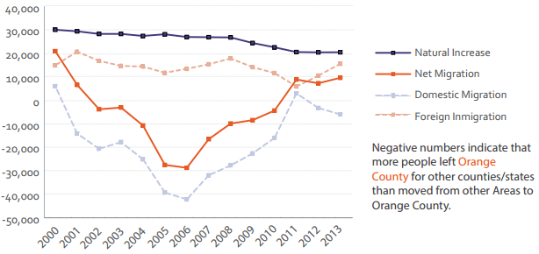
Source: 2014 UCLA/UCI Orange County on the Cusp of Change Report

Over the years, major demographic shifts have transformed OC from a predominantly Caucasian (White non-Hispanic) community in the 1960s and 1970s into a highly diverse population with various ethnic and social backgrounds. OC has attracted new immigrants for the past century—from the agricultural workforce that picked orange citrus in the 1920s to blue collar Latino and Asian assembly line workers that constructed computer and biomedical equipment starting in the 1970s to low-wage service-sector workers who now represent the largest growth sector. According to work of Pastor and Marcelli (2013), immigrants make up nearly one-third of the county’s population with 922,000 immigrants, including Somalis, Arabs, Romanians, Filipinos, Samoans, Indians, Vietnamese, Germans, Mexicans, Iranians, and more. The majority of immigrants (79 percent) arrived from 1980 to 2000, and 21 percent arrived in the last decade. These communities present both opportunities for shifting the political, social, and economic landscape of the county while also presenting the need for support and services such as language access and jobs.

The Department of Finance (2015) developed demographic projections for OC for 2015 to 2030. The initial findings indicate a 13 percent decline in the population. Table 3.1 presents steep population decline estimates in the White Non-Hispanic and African American population within the next 15 years. The Asian population shows a similar trend to the overall population projection for OC. The projections indicate there will be a minimal decline in the Hispanic population, which is estimated to represent over 50 percent of the OC population.

Table 3.1 Population 17 to 30 Years of Age by Ethnicity and Gender
Population 17 to 30 Years of Age
TOTAL POPULATION | 2015 | 2030 | Difference | % Change
Female | 290,888 | 255,614 | -35,274 | -12%
Male | 306,566 | 266,244 | -40,322 | -13%
Total Population | 597,454 | 521,858 | -75,596 | -13%
African-American | 2015 | 2030 | Difference | % Change
Female | 4,654 | 3,463 | -1,191 | -26%
Male | 5,302 | 3,566 | -1,736 | -33%
Total Population | 9,956 | 7,029 | -2,927 | -29%
Asian/Pacific Islander | 2015 | 2030 | Difference | % Change
Female | 55,325 | 45,289 | -10,036 | -18%
Male | 55,869 | 46,772 | -9,097 | -16%
Total Population | 111,194 | 92,061 | -19,133 | -17%
White (Non-Hispanic) | 2015 | 2030 | Difference | % Change
Female | 105,507 | 78,516 | -26,991 | -26%
Male | 110,956 | 83,042 | -27,914 | -25%
Total Population | 216,463 | 161,558 | -54,905 | -25%
Hispanic | 2015 | 2030 | Difference | % Change
Female | 125,402 | 128,346 | 2,944 | 2%
Male | 134,439 | 132,864 | -1,575 | -1%
Total Population | 259,841 | 261,210 | 1,369 | 1%
Source: State of California, Department of Finance

Table 3.2 Population over the Age of 65 by Ethnicity and Gender
Population Over the Age of 65
TOTAL POPULATION | 2015 | 2030 | Difference | % Change
Female | 235,364 | 378,554 | 143,190 | 61%
Male | 186,749 | 315,710 | 128,961 | 69%
Total Population | 422,113 | 694,264 | 272,151 | 64%
African-American | 2015 | 2030 | Difference | % Change
Female | 2,605 | 5,361 | 2,756 | 106%
Male | 2,186 | 4,661 | 2,475 | 113%
Total Population | 4,791 | 10,022 | 5,231 | 109%
Asian/Pacific Islander | 2015 | 2030 | Difference | % Change
Female | 45,717 | 86,833 | 41,116 | 90%
Male | 37,124 | 66,475 | 29,351 | 79%
Total Population | 82,841 | 153,308 | 70,467 | 85%
White (Non-Hispanic) | 2015 | 2030 | Difference | % Change
Female | 36,319 | 84,996 | 48,677 | 134%
Male | 27,141 | 72,386 | 45,245 | 167%
Total Population | 63,460 | 157,382 | 93,922 | 148%
Hispanic/Latino | 2015 | 2030 | Difference | % Change
Female | 150,723 | 201,364 | 50,641 | 34%
Male | 120,298 | 172,188 | 51,890 | 43%
Total Population | 271,021 | 373,552 | 102,531 | 38%
Source: State of California, Department of Finance

Table 3.2 projects 64.5 percent increase in the population over the age of 65 by 2030. The majority of the growth is found within the White non-Hispanic and African American populations.
African American OC Population

Figure 3.2 Percent African American OC Residents
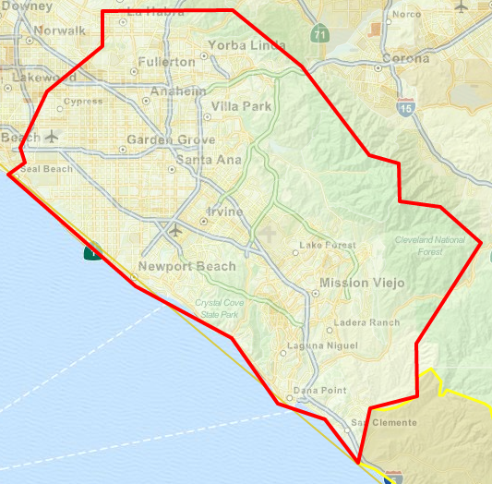
Source: City Data (based on 2000-2013 data)

The demographic map presents the population of African Americans in the OC area as less than three percent and suggests there are very small demographic population clusters in OC within this ethic group. However, outside of the region, near Riverside and Los Angeles counties are small pocket population clusters as seen in Corona, Norco, and Lakewood.

The African American population is the smallest ethnic category in OC, making up only 2.1 percent of the OC population (U.S. Census Bureau, 2015). This is reflected in the Figure 3.2, which uses data from 2000 to 2013 and shows the percentage of Orange County that is African American at the Census tract level, where the darker the color, the higher the percentage of the population of that particular race. The majority of the map is colored with light yellow, indicating that OC is comprised of a very small percentage of African Americans.

Figure 3.3 2015 OC African American Population Projection
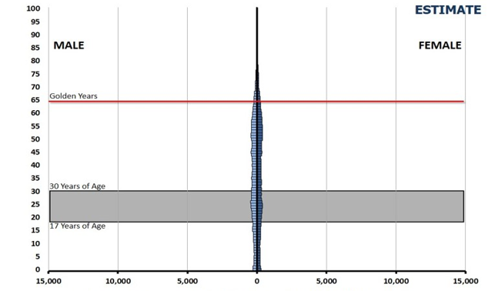
Source: State of California, Department of Finance, Race/Ethnic Population with Age and Gender Detail, 1970-2060

Figure 3.4 2030 OC African American Population Projection
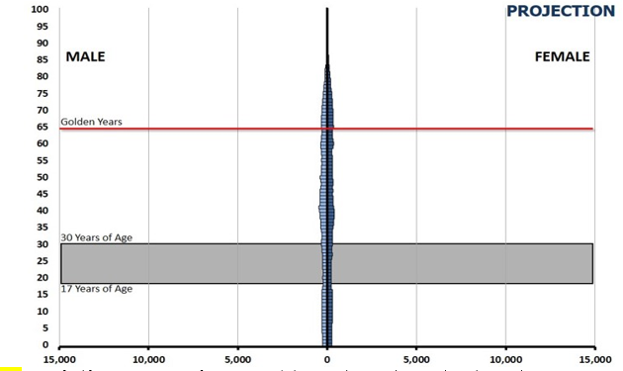
Source: State of California, Department of Finance, Race/Ethnic Population with Age and Gender Detail, 1970-2060

Figure 3.3 shows the population pyramid for African American with the same scale (increments of 5,000) as the population pyramids for the other ethnic groups. A population pyramid for the African American population with a more representative scale (increments of 200) is included in Appendix C. By 2030, African American births are expected to decline in OC while an increase in elementary-age children is projected. As shown in Table 3.1, the overall African American population 17 to 30 years of age is expected to decrease by 29 percent in the next 15 years. Also, the African American male population for this age group is projected to decrease notably more than their female counterparts—33 percent and 26 percent, respectively. In contrast, the elderly population for this ethnic group (65+) is projected to increase by 109 percent during the same time period.

Figure 3.5 Percent Asian Only, Orange County, California
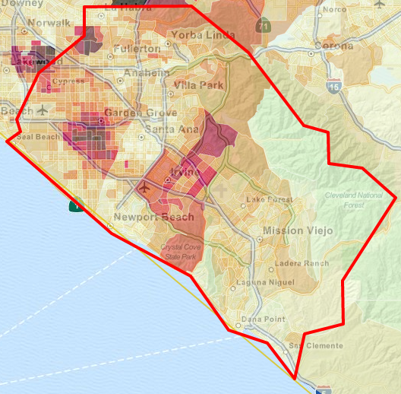
Source: City Data (based on 2000-2013 data)

Figure 3.5 includes the percentage of the Orange County population that is solely Asian (i.e., it excludes Native Hawaiian and Other Pacific Islander populations). The Asian population is most densely populated in Irvine, Fountain Valley, Westminster, and Fullerton.
Figure 3.6 2015 OC Asian Pacific/Islander Population
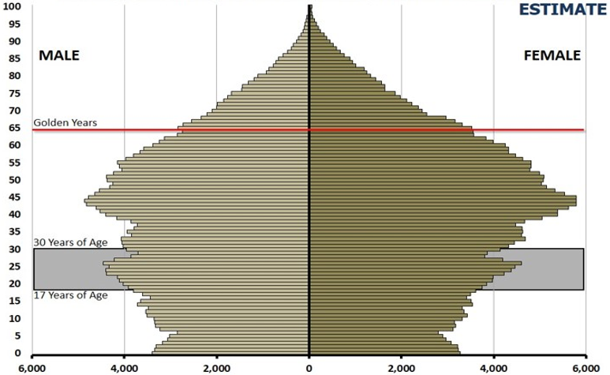
Source: State of California, Department of Finance, Race/Ethnic Population with Age and Gender Detail, 1970-2060

Figure 3.7 2030 OC Asian Pacific/Islander Population
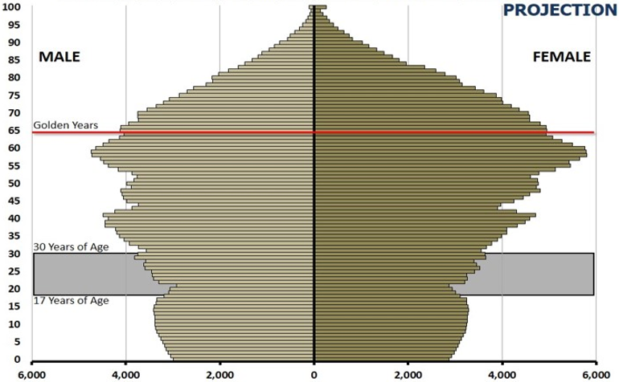
Source: State of California, Department of Finance, Race/Ethnic Population with Age and Gender Detail, 1970-2060

The college-age Asian/Pacific Islander population (age 17 to 30) is projected to decrease by 17 percent from 2015 to 2030, with very little difference in a male-female comparison. As can be seen in the population pyramid of Figure 3.7, this ethnic group, in particular, is an aging population. Specifically, by 2030 there will be an 85 percent increase in the senior population, with a 90 percent increase in the 65+ female population, and a 79 percent increase for their male counterparts.

Notably, OC has the largest Vietnamese community in the United States with 70 percent of OC Vietnamese residents being foreign born (US Census Bureau, 2010). Similar to other Asian American and Pacific Islander ethnic groups, Vietnamese are aggregated into a classification of “Asian American and Pacific Islander,” which dilutes the issues that impact each individual AAPI ethnic population. However, these diverse populations face different challenges specifically associated with education. For instance, an examination of educational attainment in a 2007 survey of adults in OC, found that, of AAPI groups as a whole, 54.5 percent report completing college whereas only 21 percent of Vietnamese report completing college. In addition, language barriers also impact the Vietnamese community as Asian Americans Advancing Justice (2013) indicated in a demographic report that the Vietnamese community has the second lowest rates of English language proficiency of all Asian groups within California.

Figure 3.8 Percent Hispanic OC Residents
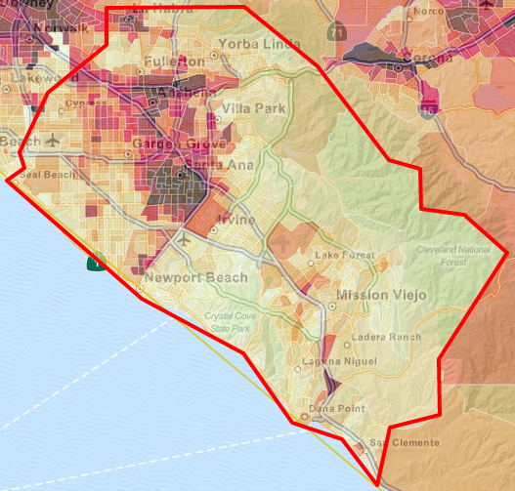
Source: City Data (based on 2000-2013 data)

The Hispanic population with OC has seen a major shift with a large growth fluctuation within the last three decades. Figure 3.8 shows that OC is heavily concentrated with Hispanics in Anaheim, Garden Grove, Santa Ana, and San Juan Capistrano, as indicated by dark pink and purple on the map.

Figure 3.9 2015 OC Hispanic/Latino Population
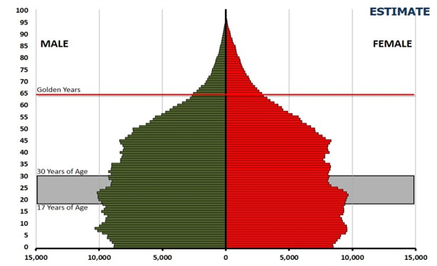
Source: State of California, Department of Finance, Race/Ethnic Population with Age and Gender Detail, 1970-2060

Figure 3.10 2030 OC Hispanic/Latino Population
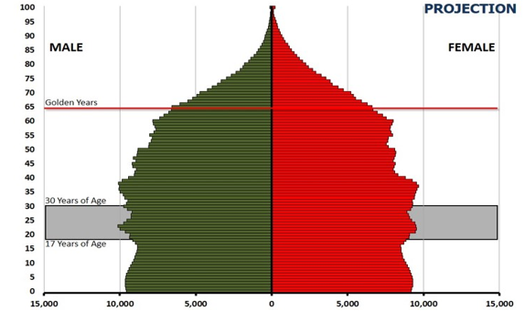
Source: State of California, Department of Finance, Race/Ethnic Population with Age and Gender Detail, 1970-2060

The population pyramid in Figure 3.10 shows that the Hispanic population is expected to increase greatly by 2030. However, the college-age population (ages 17 to 30) is projected to increase by a mere one percent (Table 3.1). In contrast, the population pyramid shows that the late middle-aged and elderly populations are expected to grow over the next 15 years. Specifically, the 65+ Hispanic population is projected to grow by 148 percent in OC by 2030, with the male elderly population projected to increase by 167 percent and the female elderly population projected to increase by a lesser 134 percent; however, the number of females is projected to remain greater than the number of 65+ males in OC.

Figure 3.11 Percent White-Non Hispanic OC Residents
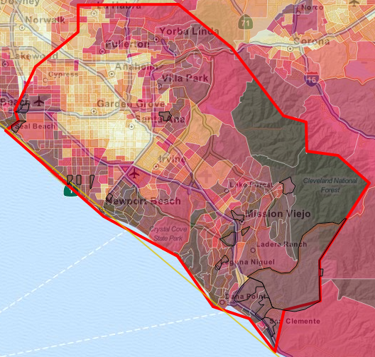
Source: City Data (based on 2000-2013 data)

Figure 3.11 shows that Orange County is densely populated with White/Non-Hispanics, particularly in Newport Beach, Mission Viejo, and Laguna Beach, as indicated by the darker pink and purple census tracts.
Figure 3.12 2015 OC White/Non-Hispanic Population
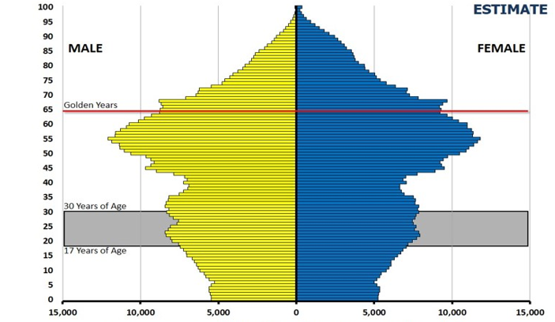
Source: State of California, Department of Finance, Race/Ethnic Population with Age and Gender Detail, 1970-2060
Figure 3.13 2030 OC White/Non-Hispanic Population
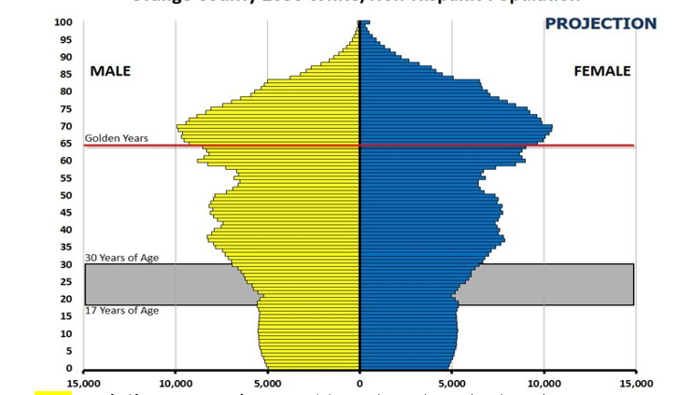
Source: State of California, Department of Finance, Race/Ethnic Population with Age and Gender Detail, 1970-2060

The population pyramids in Figure 3.13 show that the White/Non-Hispanic population is expected to shrink significantly by 2030, with a decline in births and young adults within the 17 to 30 age range. Specifically, the white college-age population (17-30 years) in Orange County is expected to decrease by 25 percent in the next 15 years. Additionally, the White population is projected to experience an increase in individuals over the age of 65 by a staggering 148 percent from over 63,000 in 2015 to over 157,000 in 2030.

Economics of Orange County

After World War II, aerospace and electronics manufacturing sectors grew dramatically in OC, sustained by postwar defense contracts. Many manufacturing plants employed a unionized workforce that was able to command family-supporting wages (Scott, 1985). In the 1990s and 2000s, the economy of OC shifted with the decrease of the military aerospace and defense contracts, the outsourcing of labor to other countries, and a decrease of large manufacturing plants to meet global economic shifts. As a result of this movement, the wages of individuals in OC suffered. Simultaneously, during the 1990s and 2000s, the economy shifted towards information and service industries.

Within last two decades, OC’s economy has shifted towards reliance on the service and information sectors, with particular emphasis on tourism. The majority of OC’s job growth in the next ten years is anticipated to take place in low-wage industries, which will create more low-wage jobs. As Figure 3.14 shows, the largest proportion of growth in the workforce is expected in the education and health services, leisure and hospitality sector, and professional services. Tourism is one of the leading industries in OC, and accounts for approximately 15 percent of the county’s employment. However, the average salary within the tourism sector was estimated at $23,707 in 2012 and shows a major variance with the cost of living in OC (California Employment Development Department, 2012).

Figure 3.14 Employment Share by Industry, 1990-2020
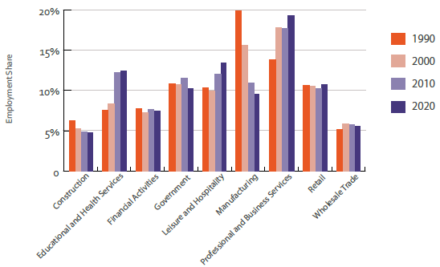
Source: 2014 UCLA/UCI Orange County on the Cusp of Change Report

As stated earlier, much of OC’s job growth in the next ten years is expected to take place in lower wage industries. As reflected in Figure 3.15, the largest numbers of jobs that will be created are concentrated in low-wage entry-level jobs that pay less than $20 per hour as shown in Figure 3.15. For instance, over 40,000 retail and restaurant jobs will be created over the next 10 years. Except for police officers, all of these jobs pay less than $20 per hour. Therefore, most of these workers would be unable to afford a one-bedroom apartment in OC (Orange County Community Indicators 2014).

Figure 3.15 Hourly Wages for Occupations with the Most Job Openings, 2010-2020
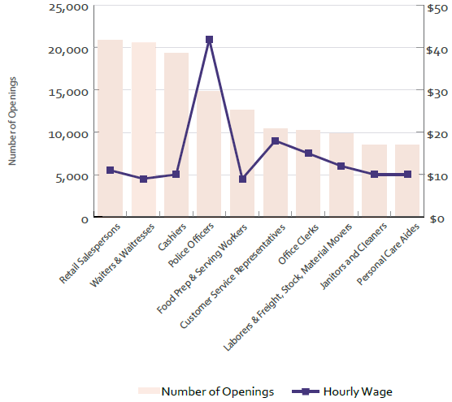
Source: 2014 UCLA/UCI Orange County on the Cusp of Change Report

High cost of living and economic inequality spread across the county. OC is among the most expensive places to live in the entire country. OC ranked 4th out of the largest 100 metropolitan areas for fastest growing income gap between the rich and the poor between 1990 and 2012 (Milbourn, 2014). The Anaheim-Irvine-Santa Ana metropolitan area is the second least affordable area in the nation to buy a home. The Cost of Living Index compares the prices of housing, consumer goods, and services in Orange County and peer metro areas. In the most recent estimates, Orange County scored 143.8 in 2013, with 100.00 being the average (Council for Community and Economic Research, 2013). Thus, it is 43.8 percent more expensive to live in Orange County than the national average (Orange County Business Council, Orange County Community Indicators, 2014). Figure 3.16 provides a graphical clustering of the income of OC residents based on median household income (U.S. Census Bureau, 2013).

Figure 3.16 Median Household Income by City, 2008-2012
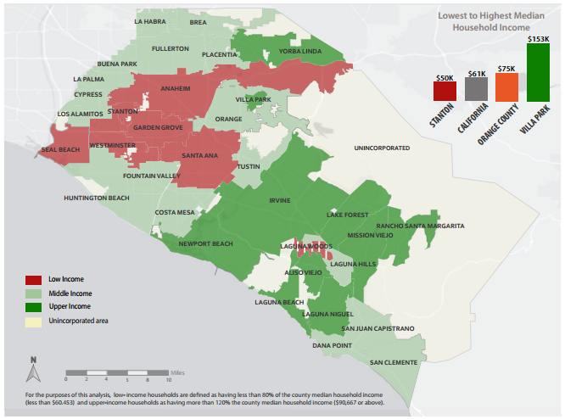
Source U.S. Census Bureau, 2008-2012 American Community Survey

Moreover, OC may potentially struggle with income inequality resulting from an economic transition that replaced thousands of well-paid professional and manufacturing jobs with low-wage service sector jobs. Job growth is expected to occur primarily in occupations that provide low wages; coupled with the region’s high cost of living, this lack of quality employment opportunity means many OC current and future residents will struggle to make ends meet.

Figure 3.17 Unemployment in Orange County, California
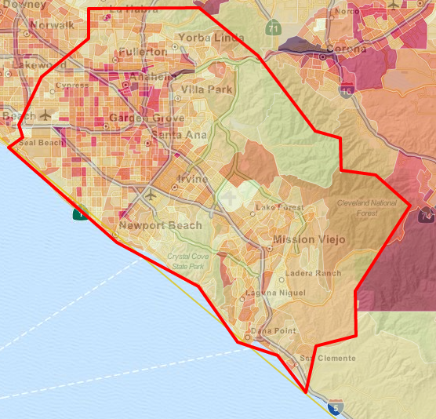Source: City Data (based on 2000-2013 data)

Figure 3.17 shows the percentage of the OC population that is unemployed. As indicated by the darker colored Census tracts, Anaheim, Garden Grove, and Santa Ana have the highest unemployment rates.

Educational Competition in Orange County

The educational climate in Orange County is plentiful with 238 high schools, of which 72.6 percent are public funded.

Table 3.3 OC High Schools
City | Private | Public | Total
Aliso Viejo, CA | 1 | 3 | 4
Anaheim, CA | 8 | 22 | 30
Brea, CA | 0 | 3 | 3
Buena Park, CA | 3 | 3 | 6
Costa Mesa, CA | 1 | 3 | 12
Cypress, CA | 3 | 3 | 6
Dana Point, CA | 0 | 2 | 2
Fountain Valley, CA | 1 | 3 | 4
Fullerton, CA | 3 | 9 | 12
Garden Grove, CA | 2 | 18 | 20
Huntington Beach, CA | 3 | 6 | 9
Irvine, CA | 4 | 15 | 19
La Habra, CA | 3 | 2 | 5
La Palma, CA | 2 | 2 | 4
Laguna Beach, CA | 0 | 1 | 1
Laguna Hills, CA | 2 | 1 | 3
Laguna Niguel, CA | 1 | 0 | 1
Laguna Woods, CA | 1 | 0 | 1
Lake Forest, CA | 1 | 2 | 3
Las Flores, CA | 0 | 1 | 1
Los Alamitos, CA | 0 | 2 | 2
Mission Viejo, CA | 4 | 9 | 13
Newport Beach, CA | 0 | 6 | 6
Newport Coast, CA | 1 | 0 | 1
Orange, CA | 3 | 6 | 9
Placentia, CA | 0 | 7 | 7
Rancho Santa Margarita, CA | 2 | 1 | 3
San Clemente, CA | 1 | 1 | 2
San Juan Capistrano, CA | 5 | 5 | 10
Santa Ana, CA | 6 | 17 | 23
Silverado, CA | 1 | 0 | 1
Tustin, CA | 1 | 3 | 4
Villa Park, CA | 0 | 2 | 2
Westminster, CA | 2 | 5 | 7
Yorba Linda, CA | 0 | 2 | 2
Total | 65 | 165 | 238
Source: National Center for Education Statistics
The high school cities that fall within the borders of the Coast Community College District include Coast Mesa, Fountain Valley, Garden Grove, Huntington Beach, Newport Beach, Newport Coast, and Westminster. The National Center for Education Statistics (2014) data indicates that of the high school enrollments throughout OC, over 25 percent of high school students are found within the service cities of the Coast District.

The Department of Finance (2015) provided a ten-year projection of K-12 enrollments within OC, with a stagnant anticipation of approximately between 36,000-37,000 high school graduates, annually.

Figure 3.18 K-12 Graduate Projections

Source: California Department of Finance, Demographic Research Unit

Within the region of OC are nine publically funded California Community Colleges. Of the colleges in OC, three make up the Coast Community College District (CCCD): Coastline Community College (Coastline), Golden West College (GWC), and Orange Coast College (OCC). In comparing annual headcounts across the nine colleges, Coastline has increased market strength over the past three years. Similarly, CCCD has increased in proportionality to the other OC districts.

Table 3.4 OC California Community Colleges
Year | 2012-2013 |  | 2013-2014 |  | 2014-2015
College | Headcount | Percent | Headcount | Percent | Headcount | Percent
Coastline | 13,395 | 5.1% | 15,351 | 5.7% | 16,765 | 6.4%
Cypress | 19,767 | 7.6% | 20,353 | 7.6% | 20,519 | 7.8%
Fullerton | 27,204 | 10.4% | 33,126 | 12.4% | 33,261 | 12.7%
Golden West | 15,796 | 6.1% | 17,161 | 6.4% | 16,959 | 6.5%
Irvine | 20,167 | 7.7% | 20,121 | 7.5% | 20,319 | 7.7%
Orange Coast | 26,629 | 10.2% | 27,863 | 10.4% | 28,379 | 10.8%
Saddleback | 38,993 | 14.9% | 37,816 | 14.1% | 36,583 | 14.0%
Santa Ana | 67,962 | 26.0% | 66,443 | 24.9% | 62,684 | 23.9%
Santiago Canyon | 31,176 | 11.9% | 29,055 | 10.9% | 26,722 | 10.2%
Source: CCCCO Data Mart
Figure 3.19 FTES comparisons

Source: CCCCO Data Mart

Though headcounts differ among institutions, the statewide-apportionment-based full-time equivalent students (FTES) measure provides a better perspective of enrollment and students served. Of the colleges in Orange County, Fullerton, Orange Coast, and Golden West had the highest FTES for the 2014-2015 academic year. Table 3.5 shows that Coastline experienced a steady decline in FTES from 0.43 in 2012-2013 to 0.41 in 2014-2015.

Table 3.5 FTES by College
College | 2012-2013 | 2013-2014 | 2014-2015
Coastline | 0.43 | 0.42 | 0.41
Cypress | 0.61 | 0.62 | 0.61
Fullerton | 0.62 | 0.71 | 0.69
Golden West | 0.61 | 0.59 | 0.62
Irvine | 0.45 | 0.47 | 0.49
Orange Coast | 0.63 | 0.63 | 0.65
Saddleback | 0.44 | 0.44 | 0.45
Santa Ana | 0.35 | 0.40 | 0.37
Santiago Canyon | 0.35 | 0.41 | 0.40
Source: CCCCO Data Mart

The competition for student enrollment can be traced down to the programs offered by the institutions. In reviewing the statewide degrees by the four-digit taxonomy of programs (TOP) code, the data over the past two years shows 125 different program options. Table 3.6 shows that the top programs for Coastline include Liberal Arts and Sciences, General-4901; Business Management-0506; and Business Administration-0505, making up 30.4 percent, 17.1 percent, and 16.9 percent of degrees earned, respectively. These top programs comprise 64.4 percent of all degrees earned at Coastline.
Tables 3.6 through 3.9 show degrees and certificates awarded by program, according to six-digit TOP code from the CCCCO’s approved award list. All award counts include Military and Contract Education, in addition to Coastline’s general student population.

Table 3.6 Three-Year Average of Degrees Awarded by Program
Program (6-Digit TOP Code) | 2012-2013 | 2013-2014 | 2014-2015 | Three-Year Average
Social and Behavioral Sciences (490100) | 495 | 387 | 399 | 427.0
Business: Business Administration, Marketing, General Business, Human Resources Management (050500) | 224 | 269 | 415 | 302.7
Supervision and Management (050630) | 189 | 187 | 211 | 195.7
Science and Math (490200) | 93 | 107 | 122 | 107.3
Electronics (093400) | 84 | 89 | 123 | 98.7
Arts and Humanities (490310) | 73 | 67 | 92 | 77.3
Health Care Management (050600) | 51 | 69 | 59 | 59.7
American Studies (220120) | 30 | 50 | 60 | 46.7
Supply Chain Management (051000) | 7 | 33 | 76 | 38.7
Computer Networking: Cisco, Microsoft, Security (070800) | 28 | 30 | 49 | 35.7
Psychology (200100) | 21 | 39 | 43 | 34.3
Paralegal Studies (140200) | 26 | 22 | 30 | 26.0
Office Support Specialist: Administrative Professional, Financial Assistant, Financial Manager, Administrative Manager, General Office Manager (051400) | 21 | 17 | 26 | 21.3
Emergency Management: Concentration in Criminal Justice (210500) | 5 | 16 | 32 | 17.7
Accounting: Bookkeeping, General Accounting, Taxation (050200) | 12 | 15 | 22 | 16.3
Human Services (210400) | 12 | 21 | 16 | 16.3
Sociology (220800) | 9 | 14 | 19 | 14.0
Economics (220400) | 4 | 9 | 17 | 10.0
Communications (490300) | 6 | 4 | 17 | 9.0
History (220500) | 9 | 9 | 4 | 7.3
Building Codes Technology: Code Professional, Combination Inspection, Combination Residential Inspection, Green Building Technology, Permit Technician (095720) | 4 | 7 | 5 | 5.3
Spanish (110500) | 3 | 5 | 7 | 5.0
Process Technology (099900) | 6 | 4 | 4 | 4.7
Health and Fitness, Physical Education and Health (083500) | 1 | 2 | 9 | 4.0
Gerontology (130900) | 1 | 3 | 6 | 3.3
English (150100) | 1 | 2 | 6 | 3.0
Art (100100) | 3 | 3 | 3 | 3.0
Emergency Management (210530) | 3 | 2 | 2 | 2.3
Mathematics (170100) | 2 | 2 | 3 | 2.3
Entrepreneurship and Small Business Management (050640) | 1 | 3 | 2 | 2.0
Business and Commerce, General (050100) | 5 | 0 | 0 | 1.7
Liberal Studies (for Teaching) (490120) | 3 | 2 | 0 | 1.7
Source: CCCCO Data Mart

Table 3.6 shows the number of degrees awarded for the last three years, along with the three-year average of degrees awarded by program, according to six-digit TOP code. The three-year average of degrees awarded is particularly useful in evaluating top degree-awarding programs because programs are commonly offered in cycles. The top five degree-awarding programs over the course of the last three years include: Social and Behavioral Sciences (490100); Business: Business Administration, Marketing, General Business, Human Resources Management (050500); Supervision and Management (050630); Science and Math (490200); and Electronics (093400), which comprise 70.7 percent of all degrees awarded from 2012-2013 to 2014-2015.

Table 3.7 Market Share of 2014-2015 Degrees Awarded by Program
Program (6-Digit TOP Code) | CCC | Number of Degrees from Other OC CCs | Avg. Degrees from Other OC CCs | Market Share
Gerontology (130900) | 6 | 0 | 0 | 100.0%
Emergency Management (210530) | 2 | 0 | 0 | 100.0%
Supply Chain Management (051000) | 76 | 0 | 0 | 100.0%
Process Technology (099900) | 4 | 0 | 0 | 100.0%
Supervision and Management (050630) | 211 | 3 | 0 | 98.6%
Electronics (093400) | 123 | 13 | 2 | 90.4%
Computer Networking: Cisco, Microsoft, Security (070800) | 49 | 10 | 1 | 83.1%
Office Support Specialist: Administrative Professional, Financial Assistant, Financial Manager, Administrative Manager, General Office Manager (051400) | 26 | 9 | 1 | 74.3%
American Studies (220120) | 60 | 22 | 3 | 73.2%
Building Codes Technology: Code Professional, Combination Inspection, Combination Residential Inspection, Green Building Technology, Permit Technician (095720) | 5 | 4 | 1 | 55.6%
Human Services (210400) | 16 | 15 | 2 | 51.6%
Spanish (110500) | 7 | 7 | 1 | 50.0%
Health and Fitness, Physical Education and Health (083500) | 9 | 11 | 1 | 45.0%
Paralegal Studies (140200) | 30 | 51 | 6 | 37.0%
Health Care Management (050600) | 59 | 142 | 18 | 29.4%
Business: Business Administration, Marketing, General Business, Human Resources Management (050500) | 415 | 1,312 | 164 | 24.0%
Arts and Humanities (490310) | 92 | 317 | 40 | 22.5%
Economics (220400) | 17 | 63 | 8 | 21.3%
Accounting: Bookkeeping, General Accounting, Taxation (050200) | 22 | 86 | 11 | 20.4%
Entrepreneurship and Small Business Management (050640) | 2 | 8 | 1 | 20.0%
Emergency Management: Concentration in Criminal Justice (210500) | 32 | 149 | 19 | 17.7%
Social and Behavioral Sciences (490100) | 399 | 2,049 | 256 | 16.3%
Science and Math (490200) | 122 | 924 | 116 | 11.7%
Sociology (220800) | 19 | 303 | 38 | 5.9%
Psychology (200100) | 43 | 736 | 92 | 5.5%
English (150100) | 6 | 114 | 14 | 5.0%
Art (100100) | 3 | 60 | 8 | 4.8%
History (220500) | 4 | 129 | 16 | 3.0%
Mathematics (170100) | 3 | 186 | 23 | 1.6%
Communications (490300) | 17 | 1,170 | 146 | 1.4%
Source: CCCCO Data Mart

Table 3.7 shows the number of degrees awarded by Coastline in 2014-2015 and the number of degrees awarded by the remaining eight community colleges in Orange County for the same year. Also included is the average number of degrees awarded for those eight community colleges in order to compare the number of degrees awarded by Coastline for a particular program relative to those awarded by the average community college in the county. Finally, compared to counts, market share, or the number of degrees awarded by Coastline for a particular program out of the total degrees awarded for all of Orange County for that program better represents Coastline’s degrees awarded by program.

Programs with all or nearly all of the market share in 2014-2015 include: Gerontology (130900) (100 percent), Emergency Management (210530) (100 percent), Supply Chain Management (051000) (100 percent), Process Technology (099900) (100 percent), and Supervision and Management (050630) (98.6 percent).

Table 3.8 Three-Year Average of Certificates Awarded by Program
Program (6-Digit TOP Code) | 2012-2013 | 2013-2014 | 2014-2015 | Three-Year Average
Business: Business Administration, Human Resources Management, Marketing, General Business (050500) | 197 | 230 | 278 | 235.0
Supervision and Management (050630) | 55 | 70 | 72 | 65.7
Paralegal Studies (140200) | 52 | 46 | 47 | 48.3
Health Care Management, Management and Supervision: Management (050600) | 25 | 41 | 43 | 36.3
Accounting: Bookkeeping, General Accounting, Taxation (050200) | 14 | 38 | 45 | 32.3
CSU General Education, IGETC (490110) | 5 | 14 | 56 | 25.0
Computer Networking: Cisco, Microsoft, Security (070800) | 19 | 14 | 31 | 21.3
Building Codes Technology: Code Professional, Combination Inspection, Combination Residential Inspection, Green Building Technology, Permit Technician (095720) | 9 | 33 | 21 | 21.0
Supply Chain Management (051000) | 6 | 4 | 24 | 11.3
Administrative Manager, Administrative Professional: Assistant, Financial Assistant, Financial Manager, General Office Manager (051400) | 12 | 12 | 8 | 10.7
Gerontology (130900) | 9 | 8 | 9 | 8.7
Health Science (126000) | 0 | 0 | 23 | 7.7
Process Technology (099900) | 8 | 6 | 8 | 7.3
Digital Media Foundations: Web Design, Web Technologies, Print Design, Motion Graphic Design (061400) | 2 | 4 | 9 | 5.0
Emergency Management (210530) | 8 | 6 | 1 | 5.0
Entrepreneurship and Small Business Management (050640) | 2 | 4 | 3 | 3.0
Retail Management (050650) | 2 | 3 | 1 | 2.0
Real Estate Broker, Real Estate Studies (051100) | 0 | 0 | 1 | 0.3
Source: CCCCO Data Mart

Data in Tables 3.8 and 3.9 pertain to CCCCO approved certificates requiring 18 or more units by six-digit TOP code. While CCCCO approved certificates require greater than or equal to 12 units, the tables include only certificates requiring 18 or more units because Coastline did not award CCCCO approved certificates requiring less than 18 units during the last three years. As shown in Table 3.8, the greatest number of certificates awarded by Coastline in the last three years come from the following programs: Business Administration, Human Resources Management, Marketing, General Business (050500); Supervision and Management (050630); Paralegal Studies (140200); Health Care Management, Management and Supervision: Management (050600); and Accounting: Bookkeeping, General Accounting, Taxation (050200). These top five certificate-awarding programs comprise 76.5 percent of all certificates awarded in the last three years.

Table 3.9 Market Share of 2014-2015 Certificates Awarded by Program
Program (6-Digit TOP Code) | Coastline | Number of Certificates from Other OC CCs | Average Certificates from Other OC CCs | Market Share
Health Science (126000) | 23 | 0 | 0.0 | 100.0%
Emergency Management (210530) | 1 | 0 | 0.0 | 100.0%
Supply Chain Management (051000) | 24 | 0 | 0.0 | 100.0%
Process Technology (099900) | 8 | 0 | 0.0 | 100.0%
Building Codes Technology: Code Professional, Combination Inspection, Combination Residential Inspection, Green Building Technology, Permit Technician (095720) | 21 | 1 | 0.1 | 95.5%
Business: Business Administration, Human Resources Management, Marketing, General Business (050500) | 278 | 18 | 2.3 | 93.9%
Supervision and Management (050630) | 72 | 10 | 1.3 | 87.8%
Health Care Management, Management and Supervision: Management (050600) | 43 | 15 | 1.9 | 74.1%
Computer Networking: Cisco, Microsoft, Security (070800) | 31 | 17 | 2.1 | 64.6%
Paralegal Studies (140200) | 47 | 42 | 5.3 | 52.8%
Gerontology (130900) | 9 | 13 | 1.6 | 40.9%
Accounting: Bookkeeping, General Accounting, Taxation (050200) | 45 | 75 | 9.4 | 37.5%
Entrepreneurship and Small Business Management (050640) | 3 | 5 | 0.6 | 37.5%
Administrative Manager, Administrative Professional: Assistant, Financial Assistant, Financial Manager, General Office Manager (051400) | 8 | 15 | 1.9 | 34.8%
Retail Management (050650) | 1 | 2 | 0.3 | 33.3%
Digital Media Foundations: Web Design, Web Technologies, Print Design, Motion Graphic Design (061400) | 9 | 57 | 7.1 | 13.6%
Real Estate Broker, Real Estate Studies (051100) | 1 | 10 | 1.3 | 9.1%
CSU General Education, IGETC (490110) | 56 | 5458 | 682.3 | 1.0%
Source: CCCCO Data Mart

Table 3.9 shows the market share of certificates awarded by program. The data show that the following five programs have the greatest market share of certificates awarded for the program among OC community colleges: Health Science (126000) (100 percent); Emergency Management (210530) (100 percent); Supply Chain Management (051000) (100 percent); Process Technology (099900) (100 percent); and Building Codes Technology: Code Professional, Combination Inspection, Combination Residential Inspection, Green Building Technology, Permit Technician (095720) (95.5 percent).

In addition to the nine California Community Colleges, there are 16 private colleges and two state-funded universities within OC, all of which are listed below.

- Anaheim University
- Argosy University
- Brandman University
- California State University, Fullerton
- Chapman University
- Concordia University at Irvine
- Hope International University
- Pacific West College of Law
- Pepperdine University, Irvine
- Soka University of America
- University of California, Irvine
- University of Phoenix, La Palma
- University of Phoenix, Costa Mesa
- University of La Verne
- University of Redlands
- Vanguard University
- Western State University College of Law
- Whittier Law School

In 2015, the California Community College Chancellors Office approved the piloting of bachelor’s degree programs at the two-year community colleges. As this trend continues to progress, it is anticipated that two-year institutions will attract more students and increase their competitiveness in the education market.

